Jacob Hair

12/3/2022

HUM 110

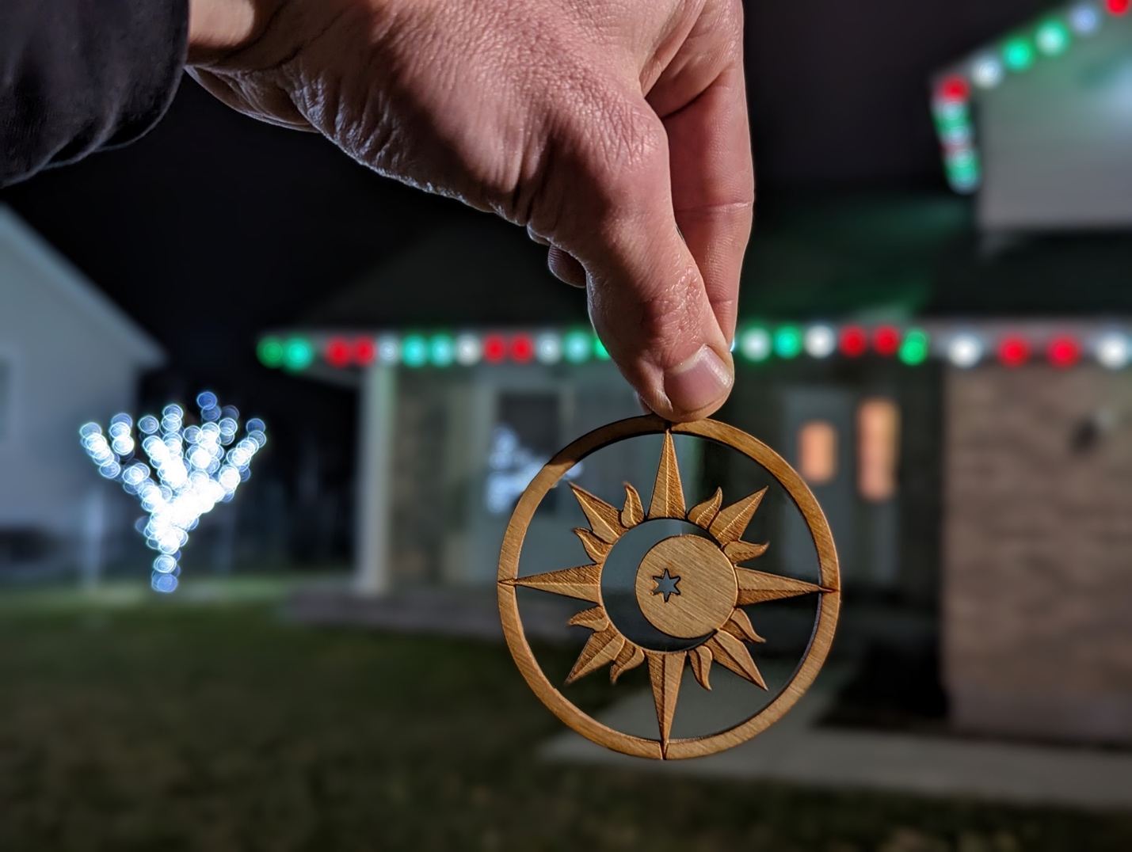

Expressionism

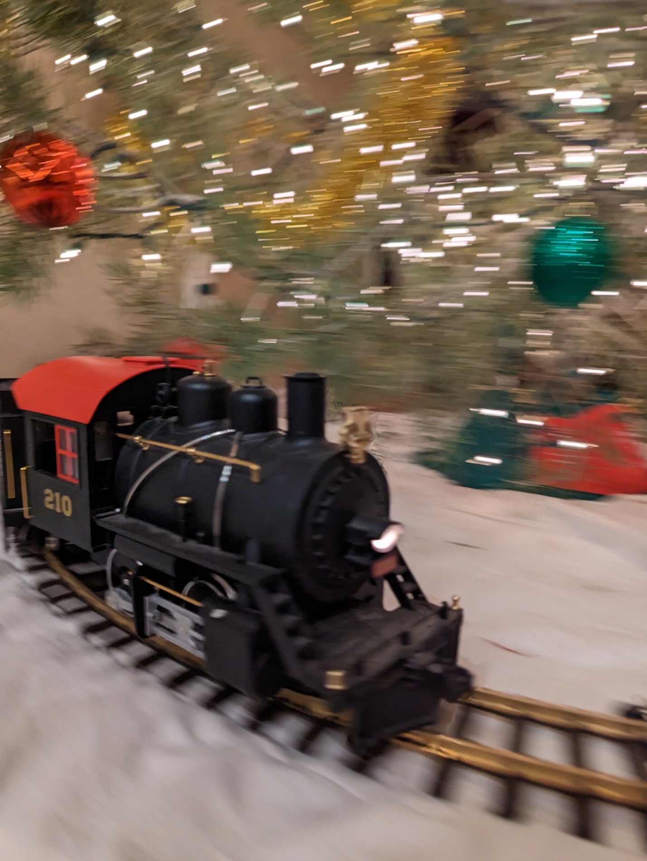

Impressionism